**Project Design Phase**

**Solution Architecture**

| Date | 31 june 2025 |
| --- | --- |
| Team ID | LTVIP2025TMID28960 |
| Project Name | Automated Car Catalog System For Enhanced Showroom Management |
| Maximum Marks | 4 Marks |

**Solution Architecture:**

The solution architecture for the Automated Car Catalog System is designed to provide a seamless, efficient, and intelligent platform for managing vehicle data and showroom requests within a modern enterprise service portal such as ServiceNow. The system begins with the Solution Interface Layer, comprising the Service Portal and Catalog Interface where showroom staff and customers can browse car categories (e.g., Sudden, Sports, XUV), view catalog items (like Polo, Thar, XUV700), and submit vehicle-related requests. Secure access is managed via Login & Authentication mechanisms such as SSO or LDAP integration. At the heart of the system lies the Car Catalog Item, developed with a responsive and interactive UI form enhanced by Client Scripts and Catalog UI Policies to control field behaviors, form validations, and dynamic visibility (e.g., showing car status or pricing based on selection). The Business Logic Layer handles backend logic using Business Rules, UI Actions, and Script Includes to automate request handling, price calculations, inventory status updates, and record creation. Flow Designer workflows are utilized to route approvals, assign showroom staff, and trigger automated notifications. To support smooth development and deployment, Update Sets are used to capture changes and migrate configurations between development, test, and production environments. An optional Integration Layer enables communication with external vehicle inventory systems or CRM tools through REST APIs or MID Server for real-time updates. The Notification Layer ensures end users and showroom teams receive timely updates through email alerts regarding request submission, approval, dispatch, or rejection. Lastly, the Reporting & Monitoring Module offers dashboards that track car availability, request status, sales trends, and SLA adherence, enabling better decision-making and showroom efficiency. This architecture enables a scalable, user-centric, and fully automated car catalog experience tailored for modern dealership operations.

**Example – Solution Architecture Diagram**

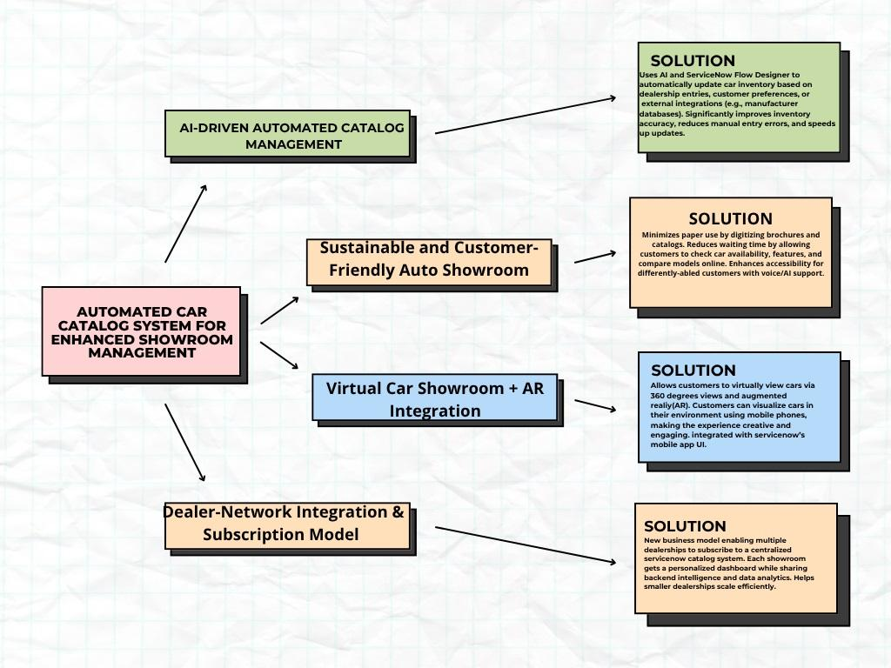

**Solution Architecture Diagram blocks for Automated Car Catalog**